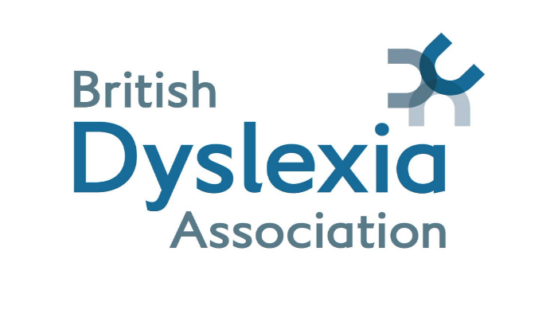

Specialist Teacher / Specialist Teacher Assessor
Application for Professional Body Membership/Accreditation (Post-Qualification)

To apply for membership of a professional body following completion of a Specialist Teacher or Specialist Teacher Assessor course, please follow the steps below:
- The course tutor (or course leader) should complete the form below and return it to the applicant as a PDF.
- The applicant should then submit this document when applying for membership to their chosen professional body/bodies.
- Applicants may also apply for relevant accreditation or certification, such as:
Assessment Practising Certificate (Assessor certification)
Teaching Practising Certificate (Specialist Teacher certification
Please note:
Applicants may hold membership with more than one professional body; however, an Assessment Practising Certificate (APC) may only be held with one body at any given time.
Professional Bodies
British Dyslexia Association: accreditation@bdadyslexia.org.uk
Dyslexia Guild: https://dyslexiaguild.org.uk/join-today/
Professional Association of Teachers of Students with Specific Learning Difficulties, PATOSS Dyslexia Charity: https://www.patoss-dyslexia.org/membership
Data Protection Declaration
By submitting this form, the applicant consents to their personal data being shared with the course provider and the professional body/bodies to which they are applying, in accordance with current data protection legislation.

Tutor Verification Section
(To be completed by the course tutor, course leader, or equivalent only)
The completed form should be saved as a PDF and returned to the applicant.

Dear BDA
I am writing to formally confirm that the candidate named below has successfully completed the following qualification:

Candidate Name: [Insert name]
Qualification Title: [Insert qualification title]
Course Title:
Awarding Organisation/Course Provider: [Insert organisation]
Date of Course Completion: [Insert date]
Level course delivered at: Level 5 or Level 7

Qualification/Accreditation to be Awarded
Either:
SpLD Specialist Teacher (ST) Level 5/Level 7 ☐
Please include candidate’s QTS number if they have one -
OR
SpLD Specialist Teacher Assessor (ST Assessor) ☐
I confirm that this qualification meets the current criteria set out by the SpLD Assessment Standards Committee (SASC) for the purposes of professional recognition and practice.
This statement is provided for verification purposes. Should you require any further information, please do not hesitate to contact me.
Yours faithfully,

Name: [Full name]
Position: [Job title]
Relevant Qualification/s: [List]
Organisation: [Organisation name]
Email / Contact Details: [Insert]

Signature:
Date:

